# Uber SnowFlake

1.How many no of customers take trip from same location.a

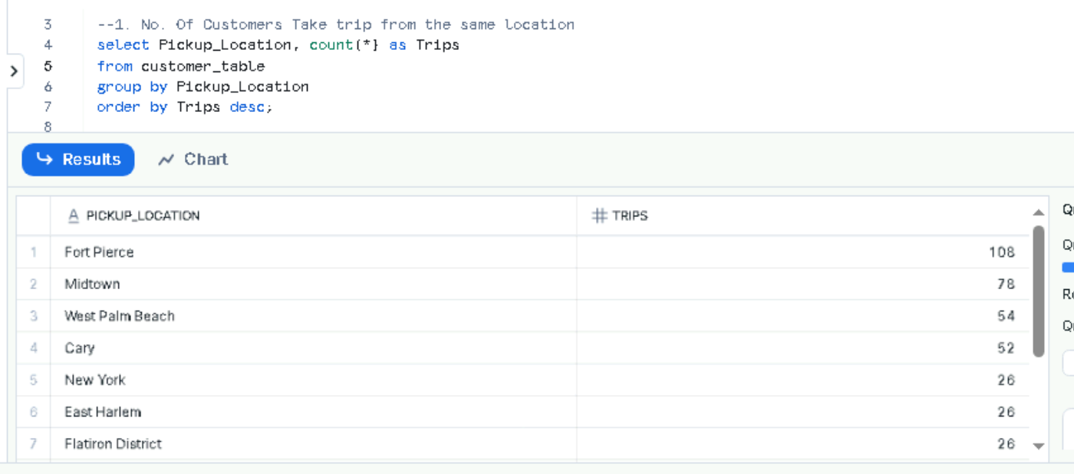

2.what is priority for each ride category from each location.

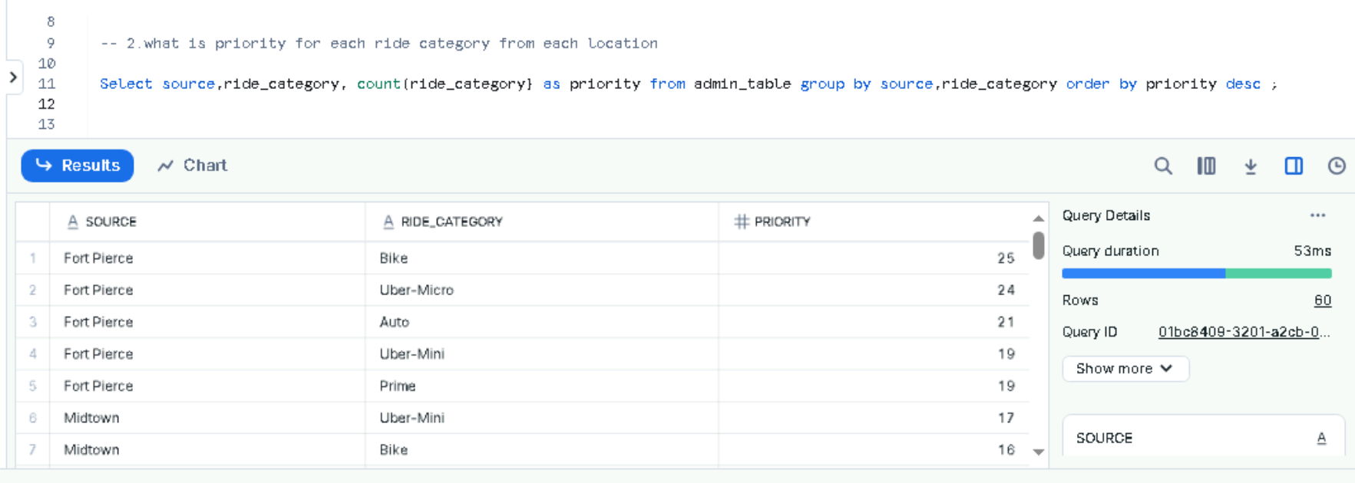

3..what are the longest locations of customer travelled.

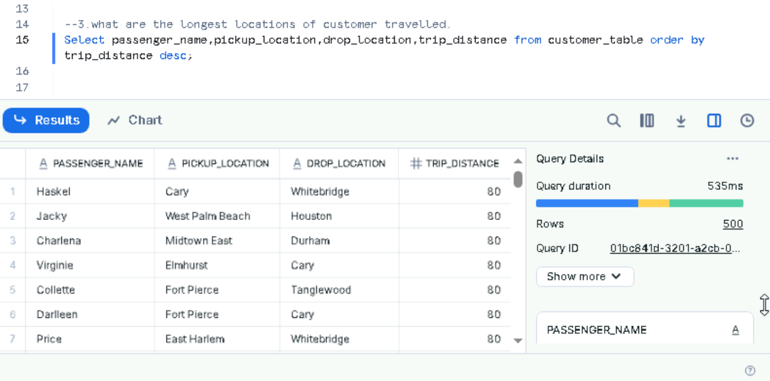

4.Drivers who completed ride with non-vaccinated customers.

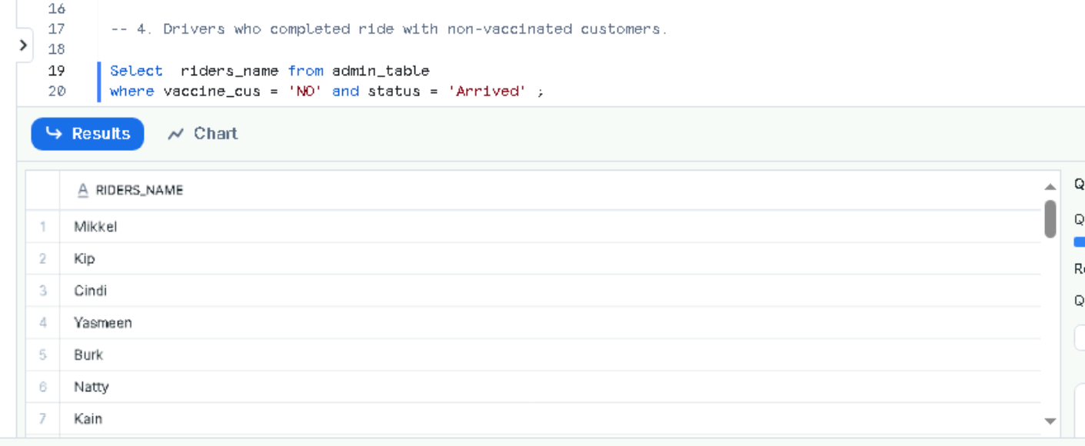

5.How many vaccinated customers have travelled.

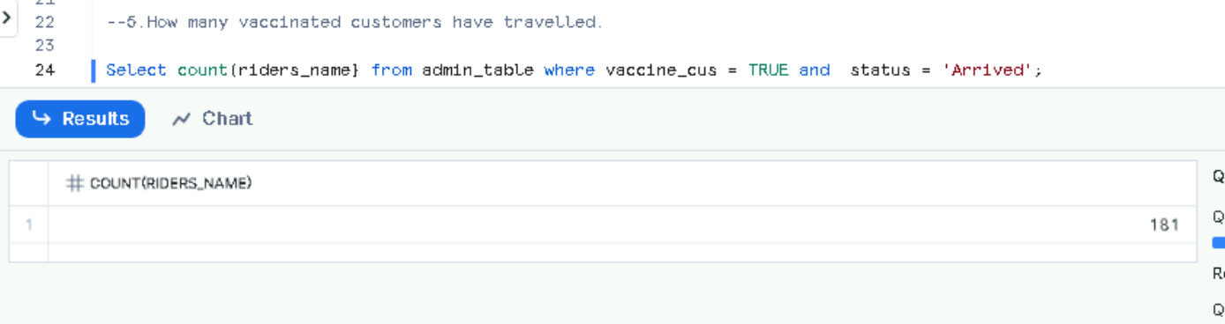

6.Customers who completed ride with non-vaccinated Drivers.

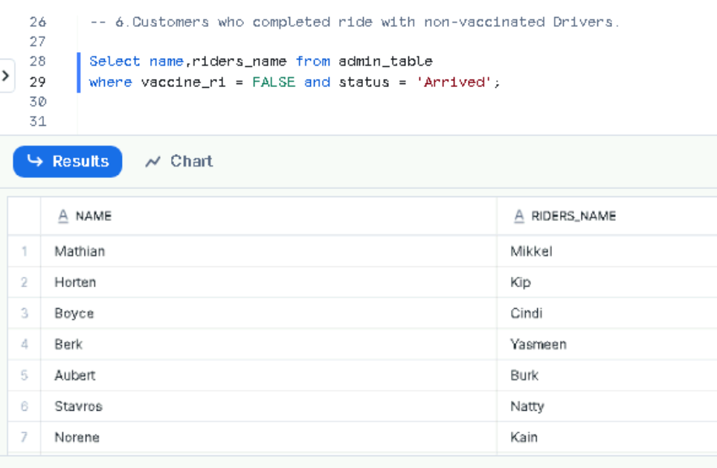

7.who is the customer completed highest no of rides.

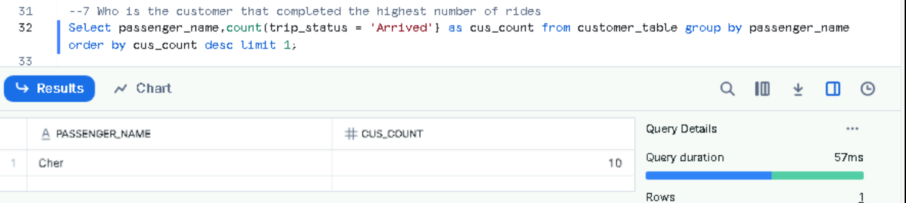

**8.**who is the driver completed highest no of rides.

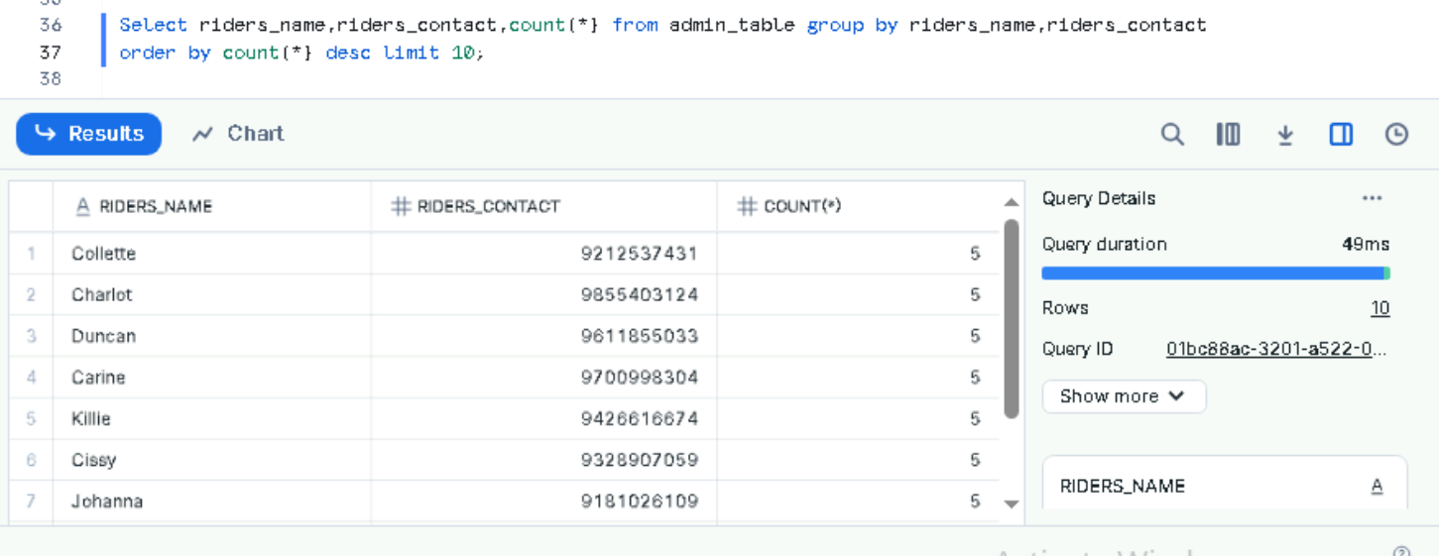

**9.** .what are first 10 age groups which uses uber services mostly.

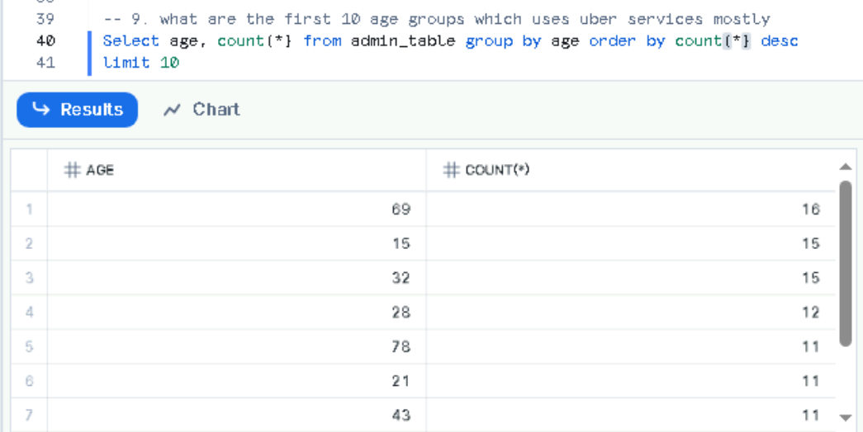

**10.**what is the count of different destination locations from same start location and also completed ride

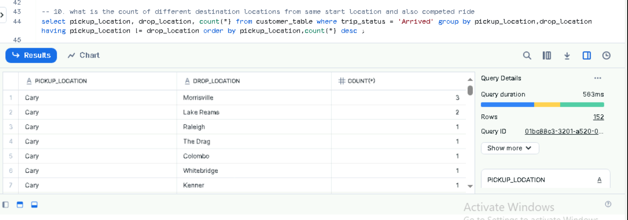

**11.**.what is the most expensive Drive

